CS 506 Programming – Python
PE08 Computer Vision in Python

10/28/2020 Developed by Jin Chang
10/28/2019 Reviewed by Kim Nguyen
School of Technology & Computing (STC)
City University of Seattle (CityU)

Before You Start
- If you have questions about the programming exercise requirements, please ask a TA to clarify.
- If you are not sure what to do:
  - Consult the resources listed below.
  - If you cannot solve the problem after a few tries, ask a TA for help.
What and how to submit
- Write Python programs to complete the exercises below.
- Once you have solved the exercises, submit the source code to Brightspace.

Introduction: We will learn about one of the fundamental image processing techniques for restoring an image with random noise called salt and pepper noise. This noise is introduced due to a limited sensing capability or pre-existing error in camera calibrations. There are many ways to remove the noise, and in this programming exercise, we will implement median filtering to reduce the noise in the image.

Input image with black and salt noise | Output image after median filter
 | 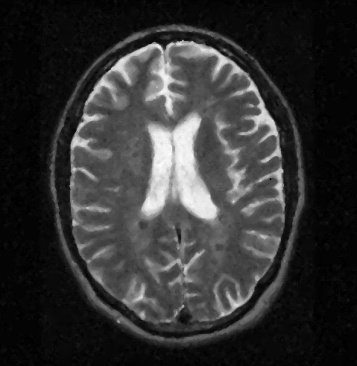

Algorithm: The median filtering applies a nonlinear method operation that is windowing (c.f. convolution operation) through the images. NxN kernel would have a list of N * N values during each iteration. From the list, you would sort the list and find the median value while discarding black (lower pixel values) and white (higher pixel values). Then, the median value will replace the original value. It removes the noise while avoiding the impact of noise on calculating the filtering values.

The 3x3 kernel window located at row=1 and col=1 will have a list of 9 values, as in [10, 12, 20, 20, 23, 24, 24, 30, 112] after sorting the list. The list's median value would be 23, and it would replace its original value, 112, as shown in the image on the right.
Before Median Filter (row=1, col=1) | After Median Filter at (1, 1)
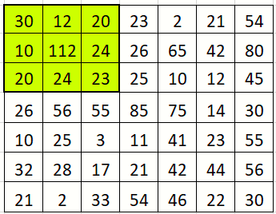 | 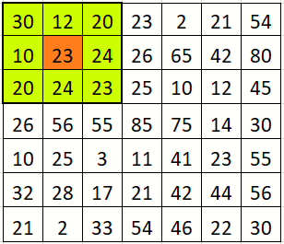

Pseudo code: The following pseudo code does not necessarily follow Python code syntax, but it provides the processing steps to accomplish the concept described above.

